­­



Submitted to

:

Mam Humaira Batool

***BS-Software Engineering 4th-E***

Title: LAB Exercise 2

DBMS

Hamza Mehmood

Roll# SP-21-110

NUML-S21-23530



National University of Modern Languages

DBMS (MySQL)

# Chapter # 2 Exercise

**Question # 01**

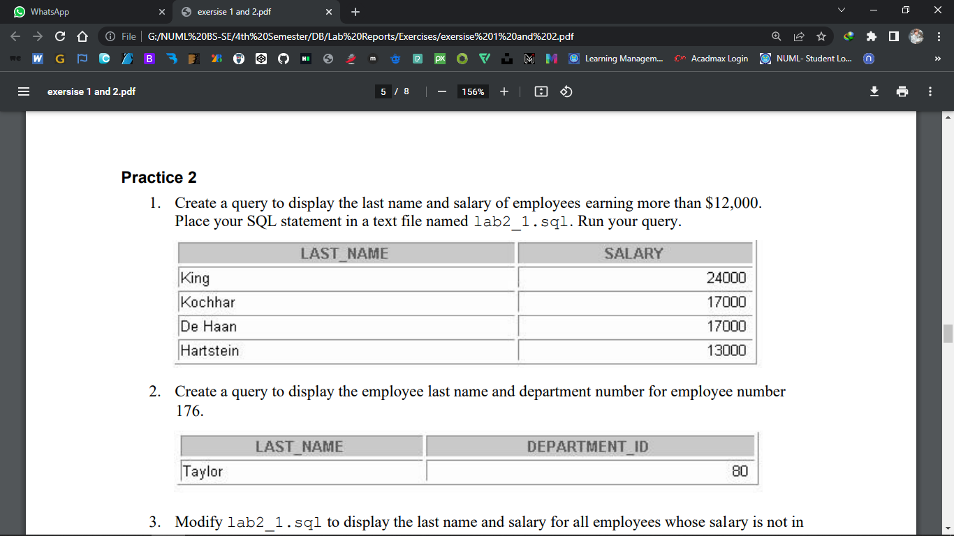

**Answer**: **SELECT last_name, salary**

**FROM employees**

**WHERE salary > 12000;**

**Question #02**



**Answer: SELECT last_name, department_id**

**FROM employees**

**WHERE employee_id = 176;**

**Question # 03**

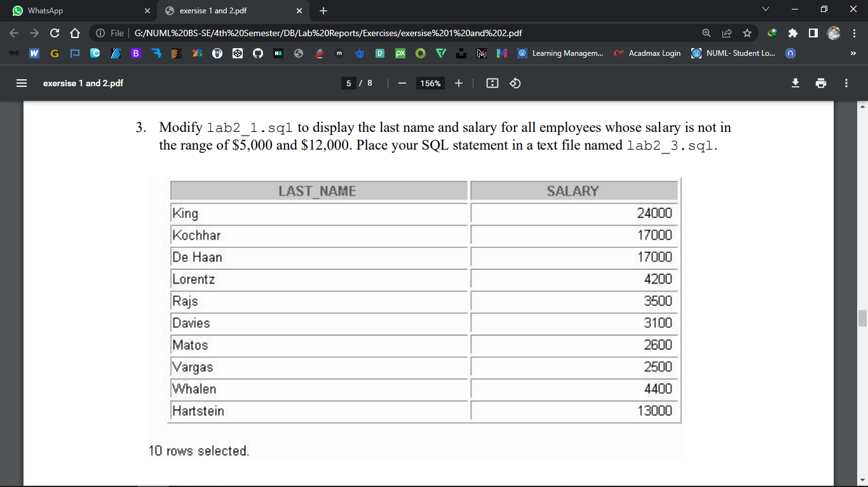

**Answer: SELECT last_name, salary**

**FROM employees**

**WHERE salary NOT BETWEEN 5000 AND 12000;**

**Question # 04**



**Answer: SELECT last_name, job_id, hire_date**

**FROM employees**

**WHERE hire_date BETWEEN '20-Feb-1998' AND '01-May-1998'**

**ORDER BY hire_date;**

**Question # 5**

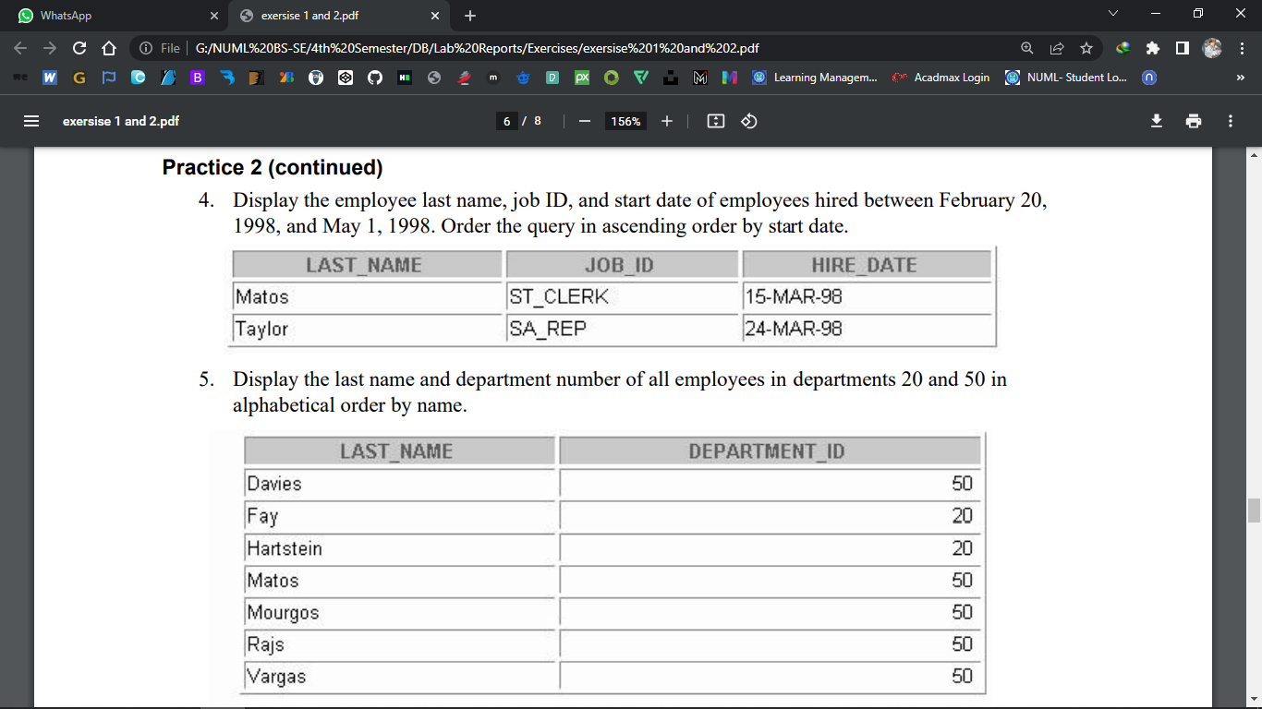

**Answer: SELECT last_name, department_id**

**FROM employees**

**WHERE department_id IN (20, 50)**

**ORDER BY last_name;**

**Question #06**

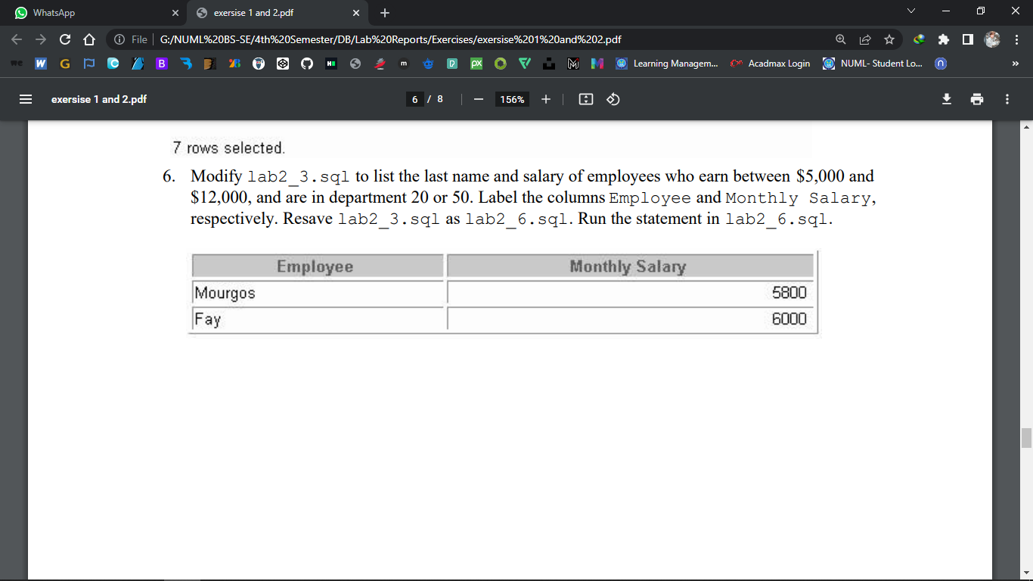

**Answer:** **SELECT last_name "Employee", salary "Monthly Salary"**

**FROM employees**

**WHERE salary BETWEEN 5000 AND 12000 AND department_id IN (20, 50);**

**Question # 7**

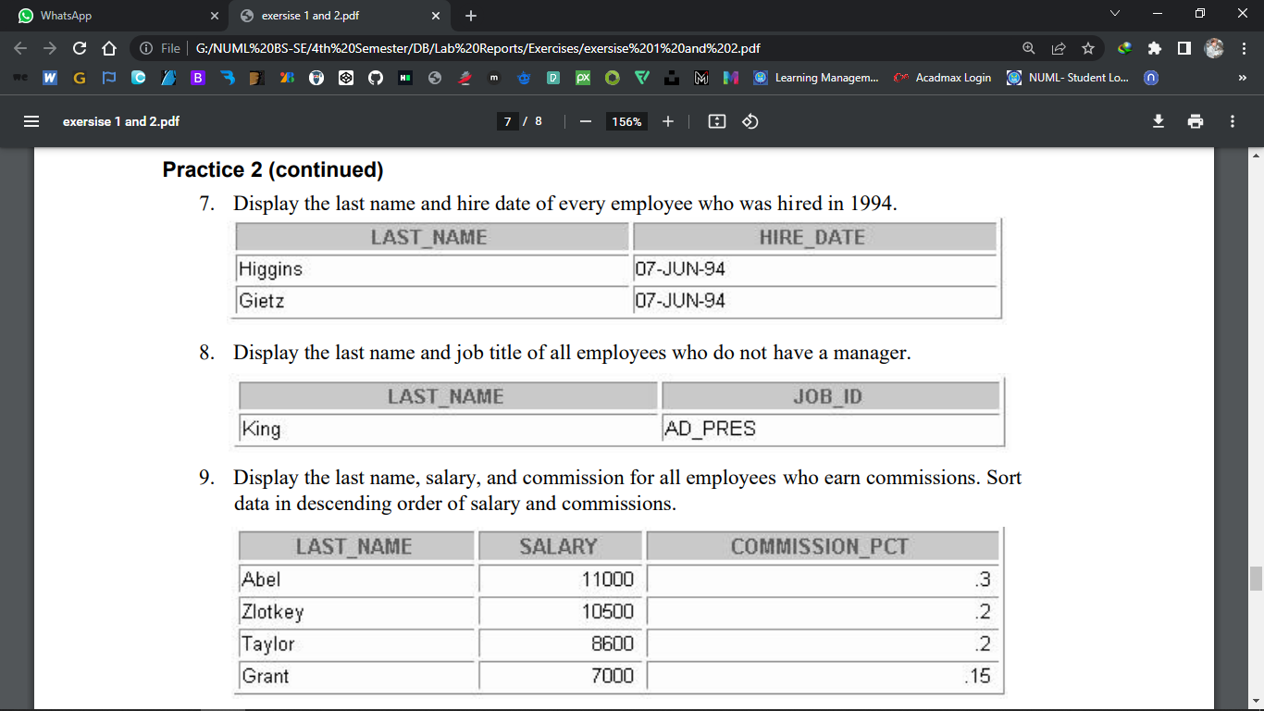

**Answer:**

**SELECT last_name, hire_date**

**FROM employees**

**WHERE hire_date LIKE '%94';**

**Question # 08**



**Answer:**

**SELECT last_name, job_id**

**FROM employees**

**WHERE manager_id IS NULL;**

**Question # 9**



**Answer:**

**SELECT last_name, salary, commission_pct**

**FROM employees**

**WHERE commission_pct IS NOT NULL**

**ORDER BY salary DESC, commission_pct DESC;**

**Question # 10**

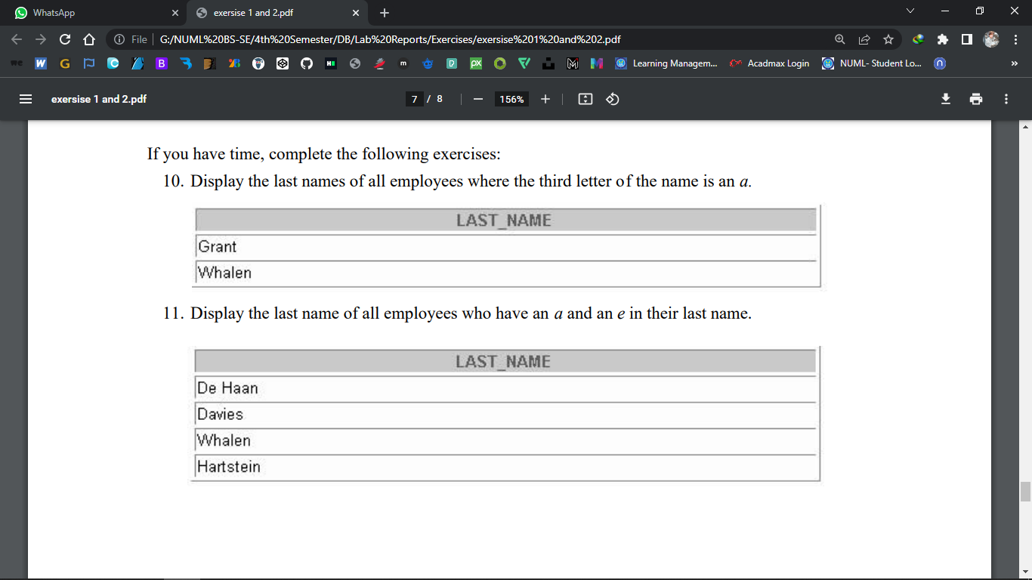

**Answer**

**SELECT last_name**

**FROM employees**

**WHERE last_name LIKE '__a%';**

**Question # 11**



**Answer**

**SELECT last_name**

**FROM employees**

**WHERE last_name LIKE '%a%'**

**AND last_name LIKE '%e%';**

**Question # 12**

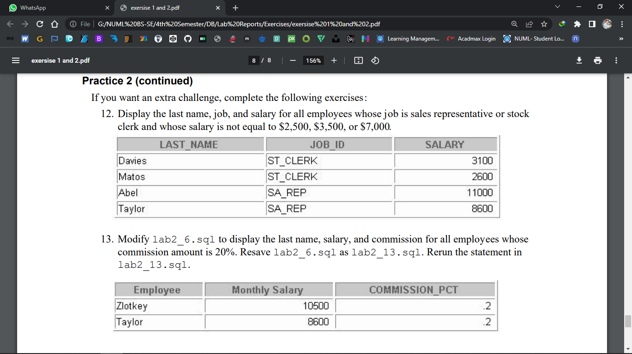

**Answer:**

**SELECT last_name, job_id, salary**

**FROM employees**

**WHERE job_id IN ('SA_REP', 'ST_CLERK')**

**AND salary NOT IN (2500, 3500, 7000);**

**Question # 13**



**Answer:.**

**SELECT last_name "Employee", salary "Monthly Salary",**

**commission_pct**

**FROM employees**

**WHERE commission_pct = .20;**